**FULL TUTORIAL FOR .EDU EMAIL BENEFITS**

1. **Office 365 for student**

go to: <https://products.office.com/en-us/student/office-in-education>

and input your email.

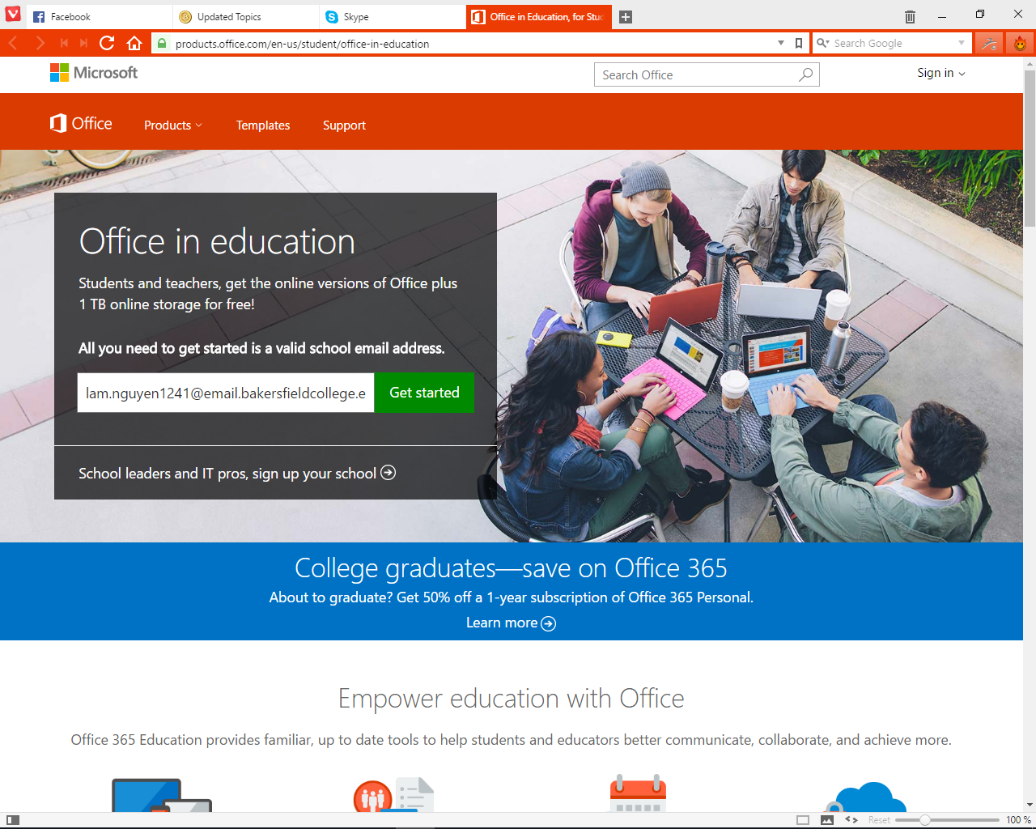

Choose I am a student

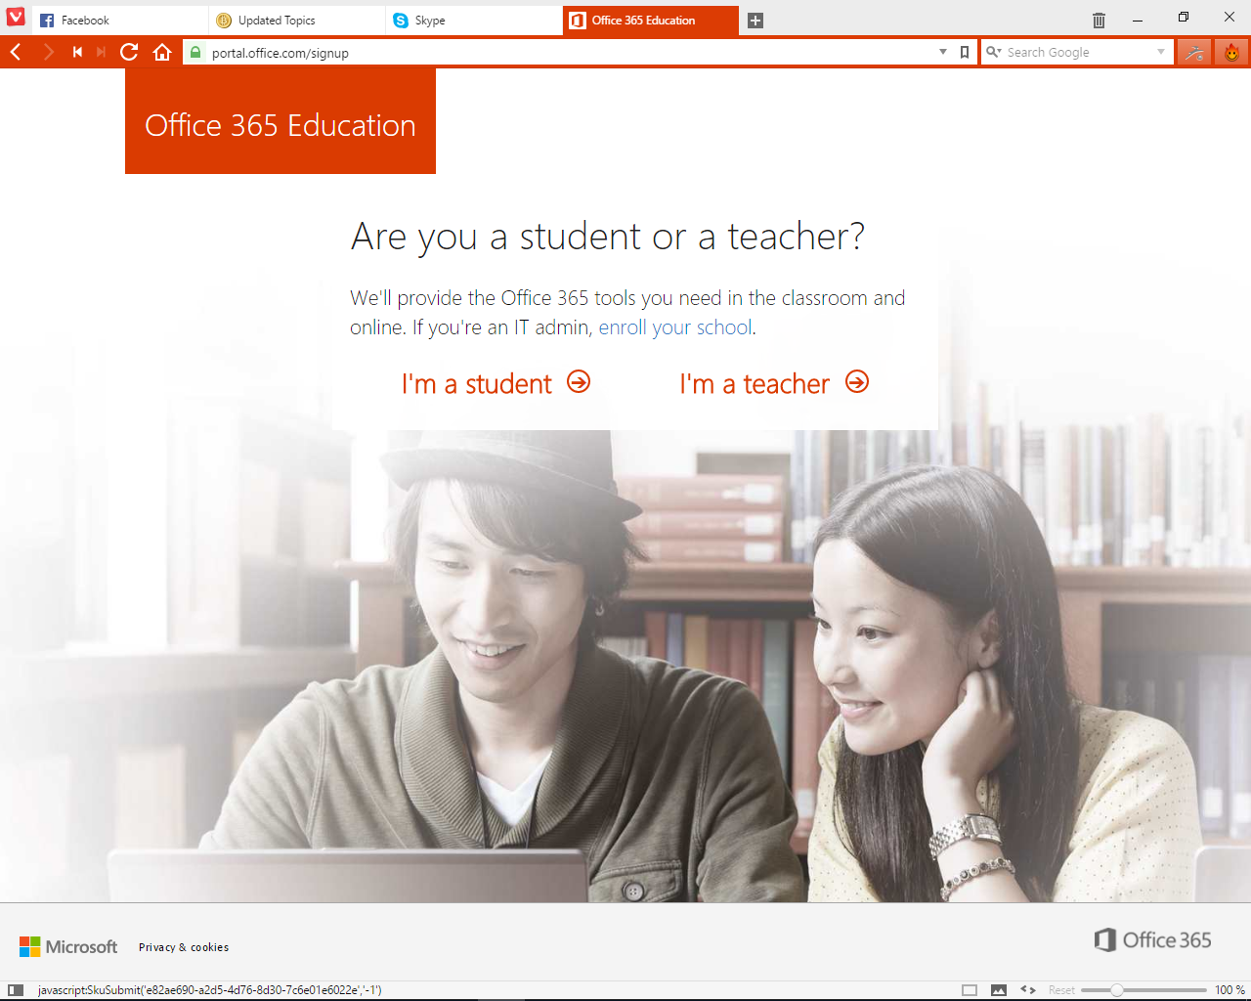

Click sign in button

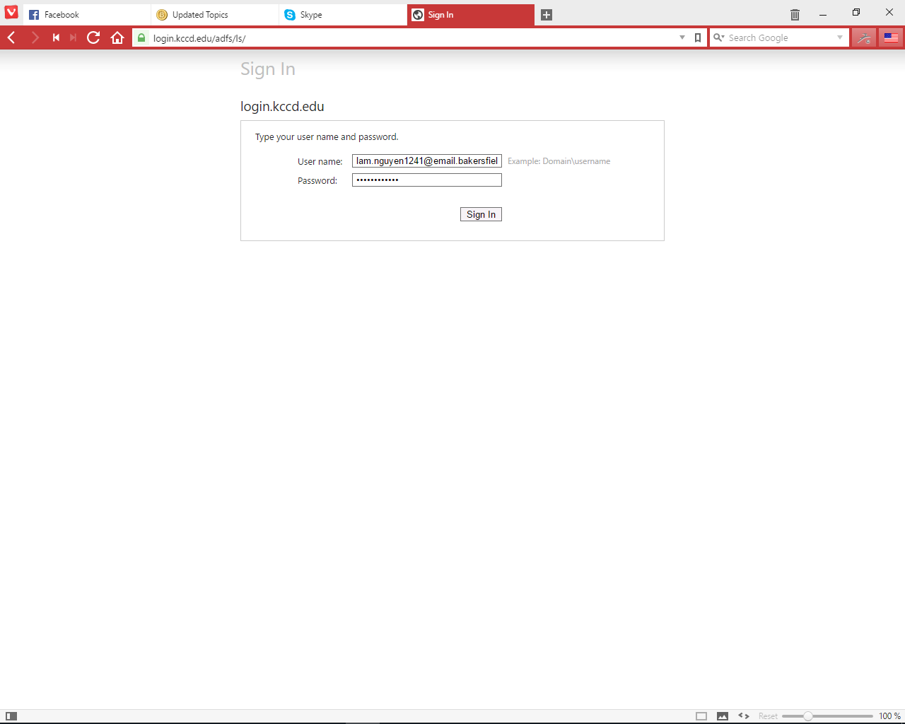

Login with your email and password



Then click Start

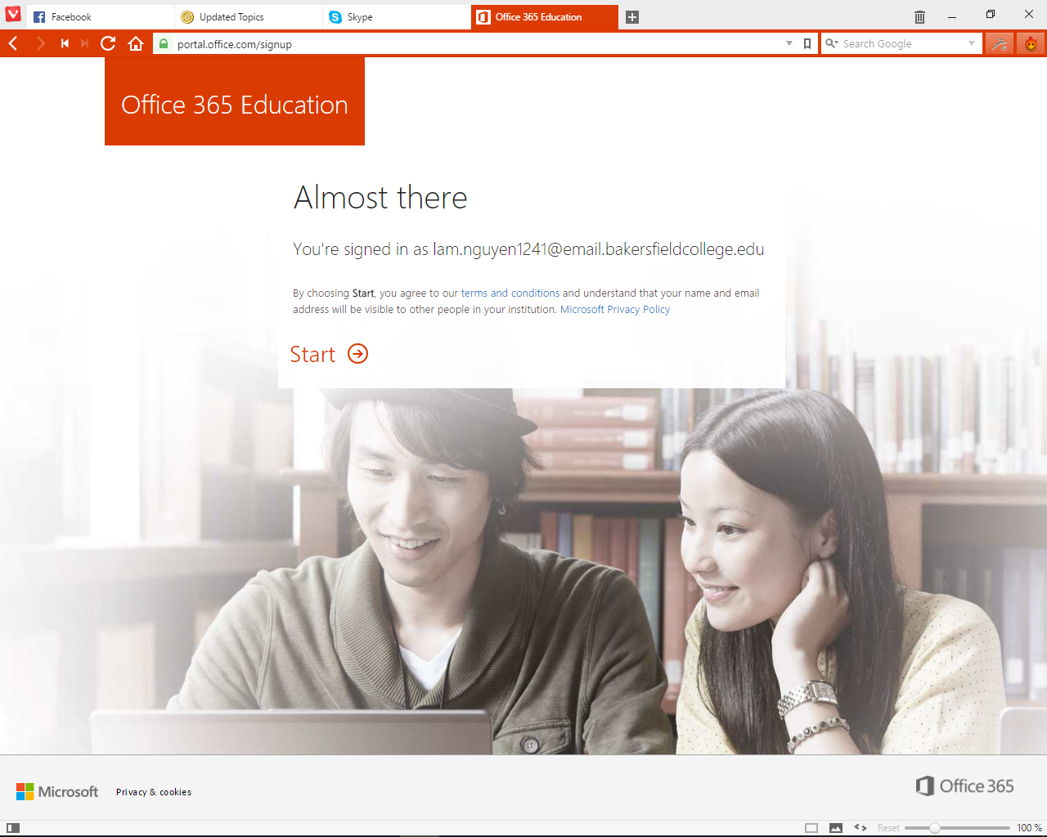

You can invite more but you will need more email (just skip this)

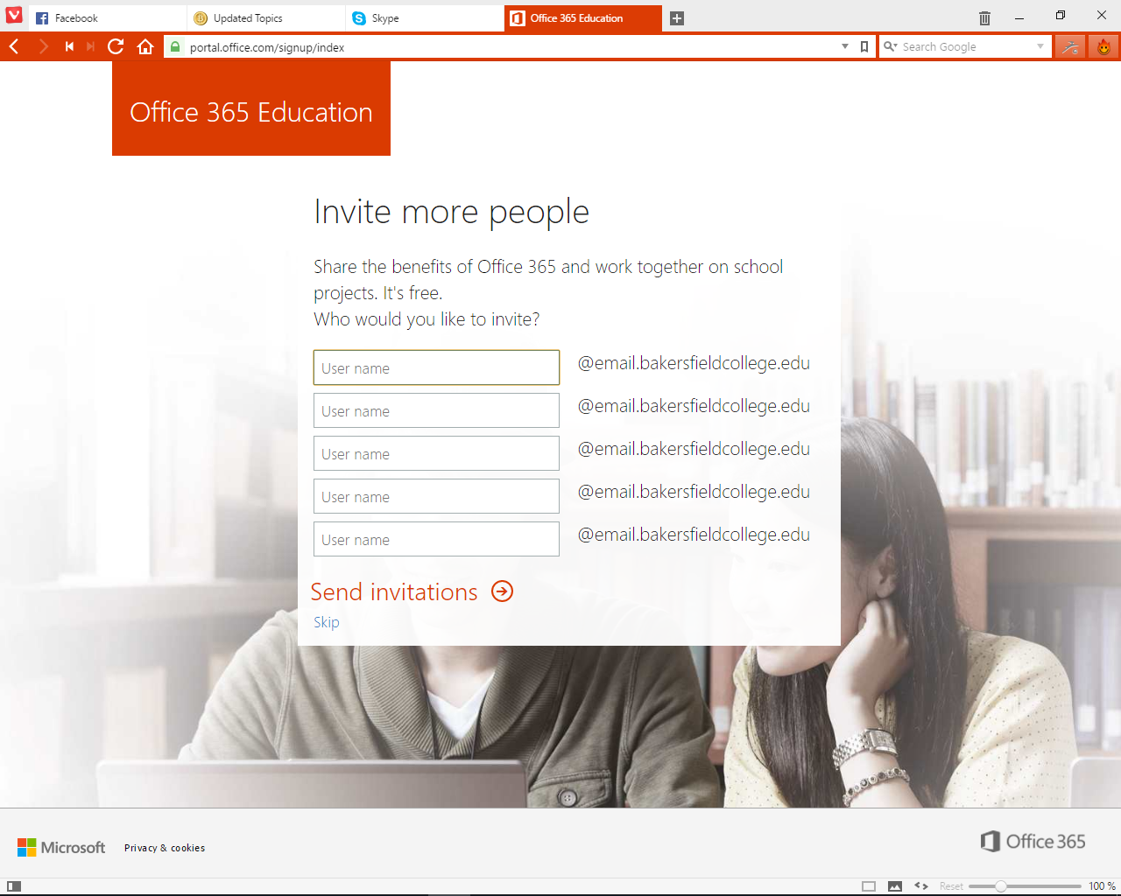

And you are ready to download, install and start using it!

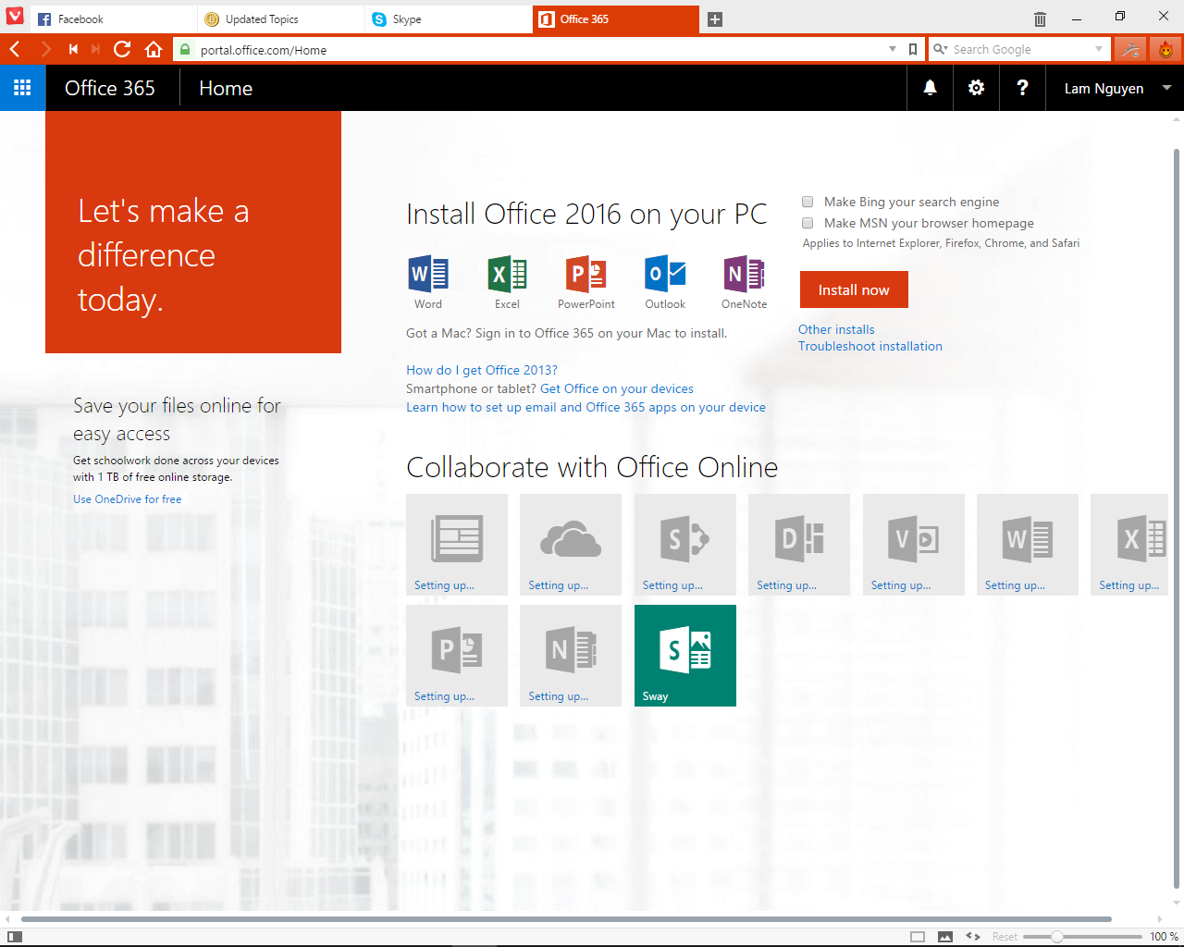

1. **GitHub education pack**

Go to: <https://education.github.com/>

And click Get the pack

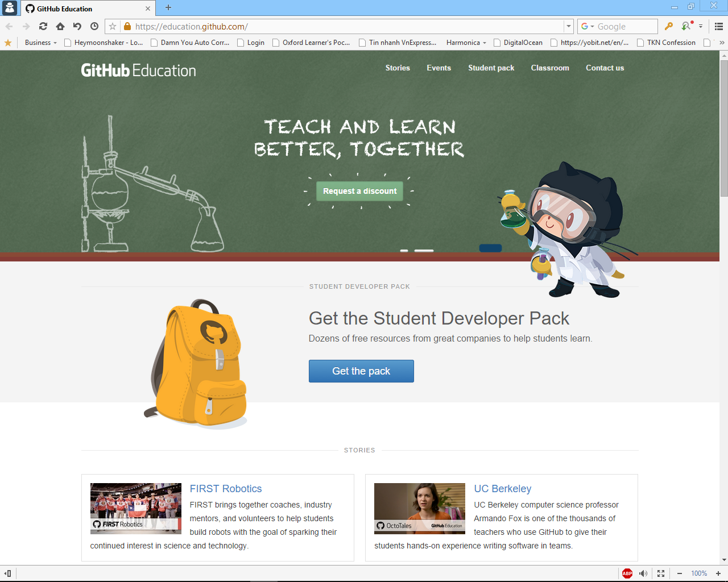

Then click Get your pack

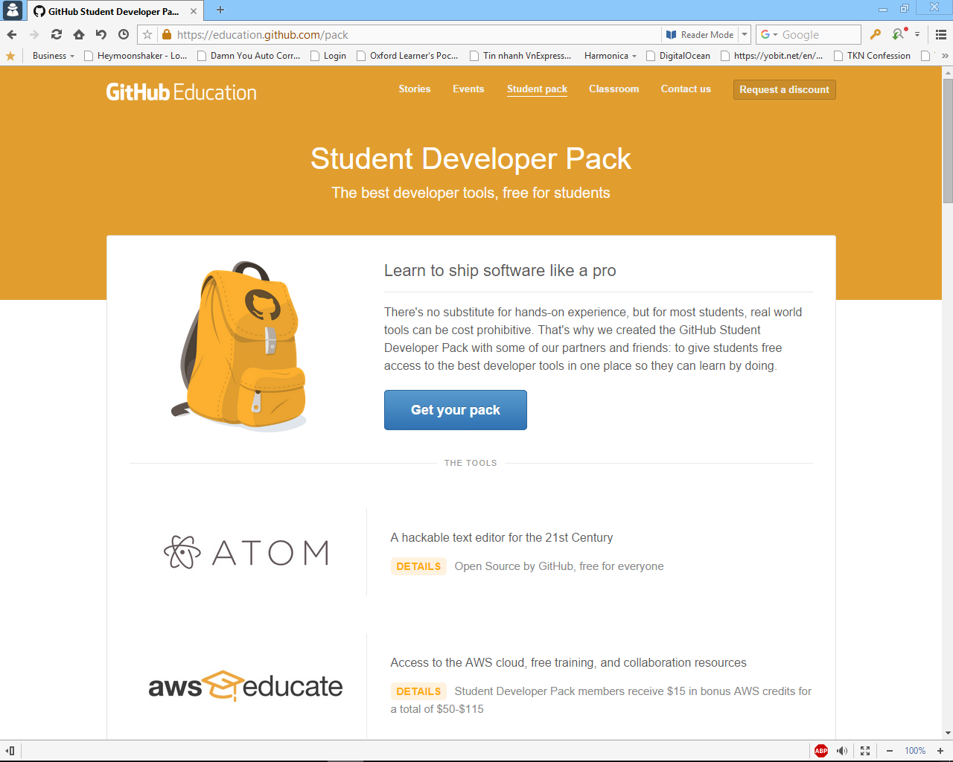

Then click create an account which will guide you here

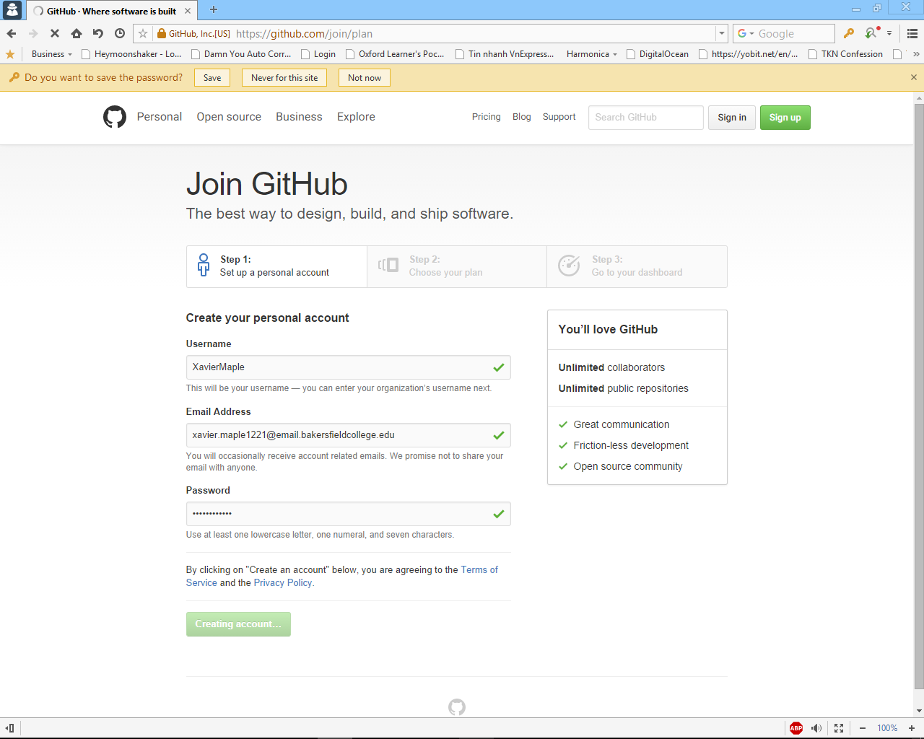

Just press Finish the registration

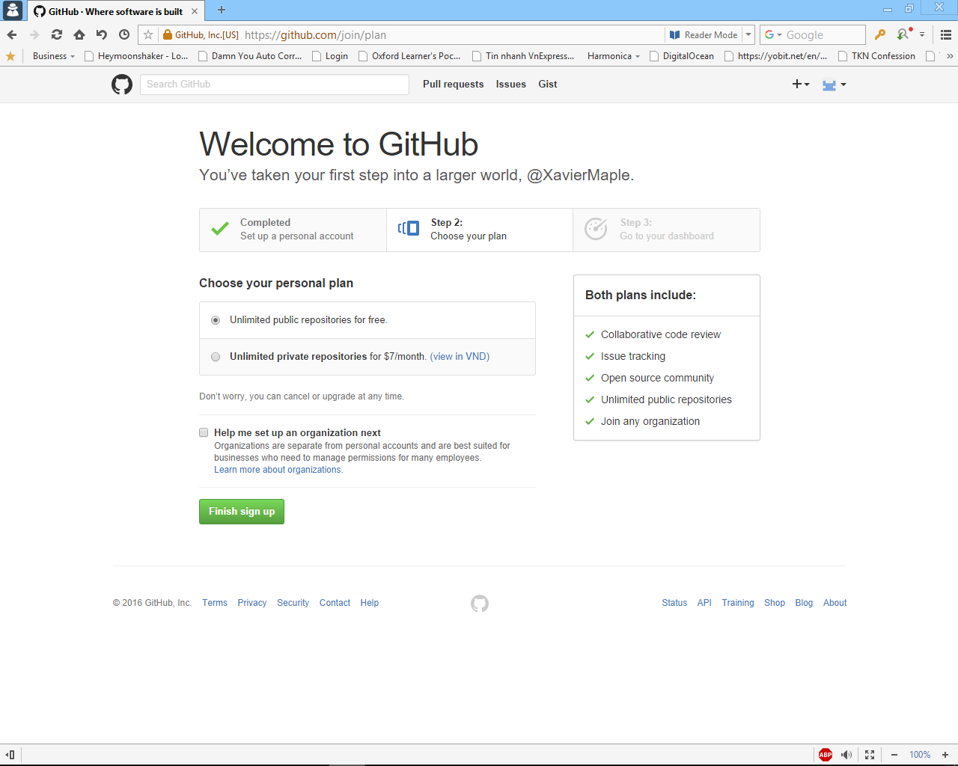

Then within minutes you will receive an email with your edu email. Click the link inside to verify your account

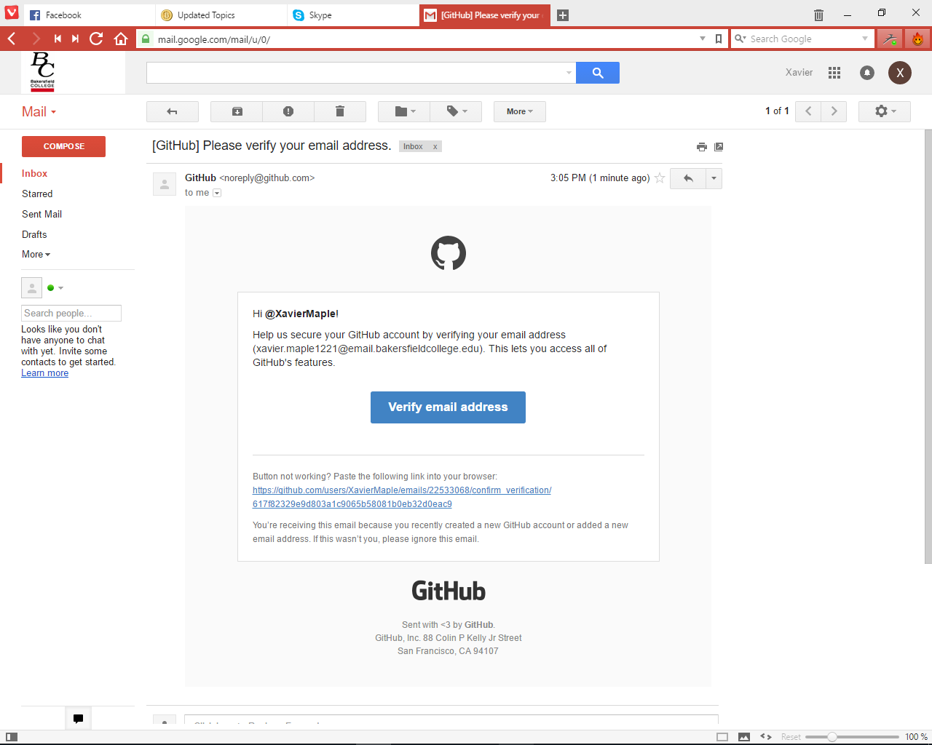

After verifying your account back to the page after click Finish sign up. Click Yes I am a student

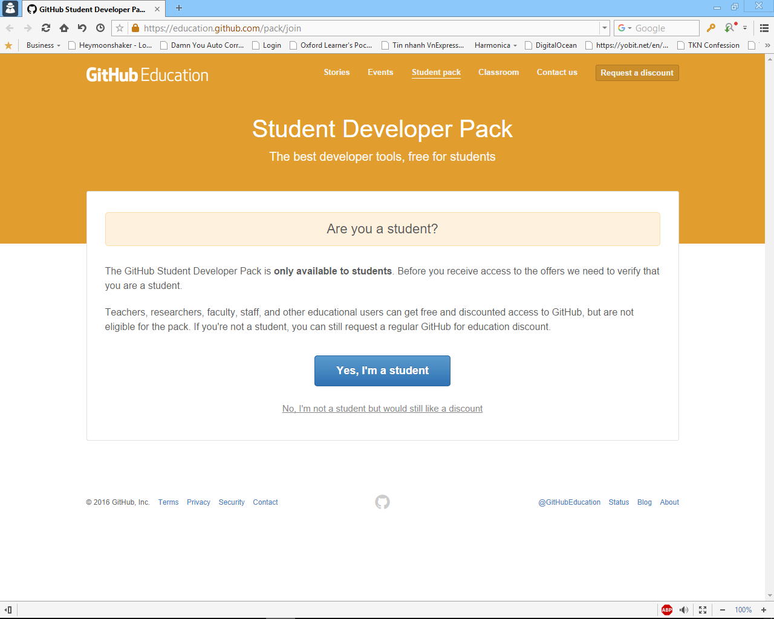

Fill in the same as I did and click Submit Request

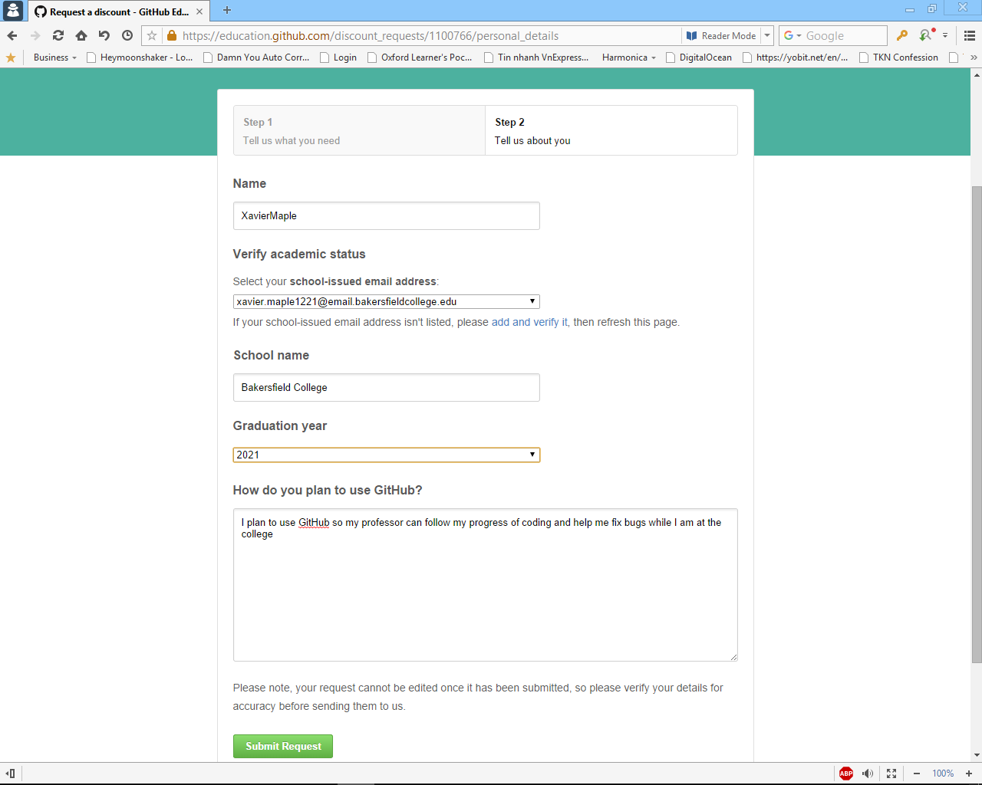

Like they said, you will receive an email from them in weeks (maybe a week, a month or instantly!)

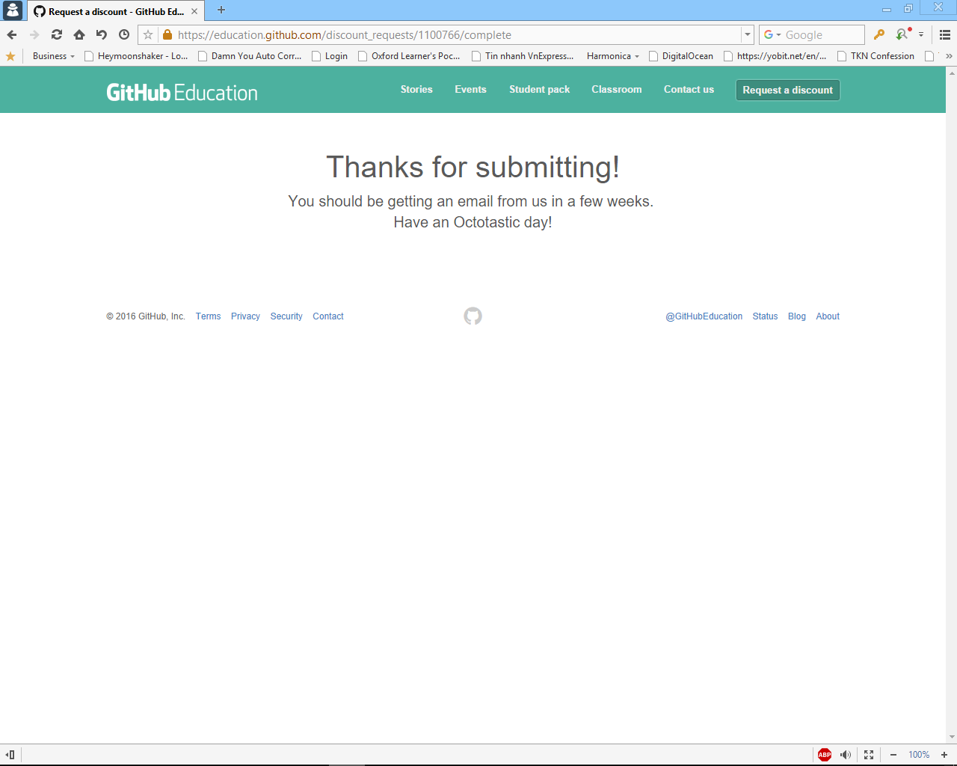

Here’s the email you are looking for. Click on the second link to get to the page.

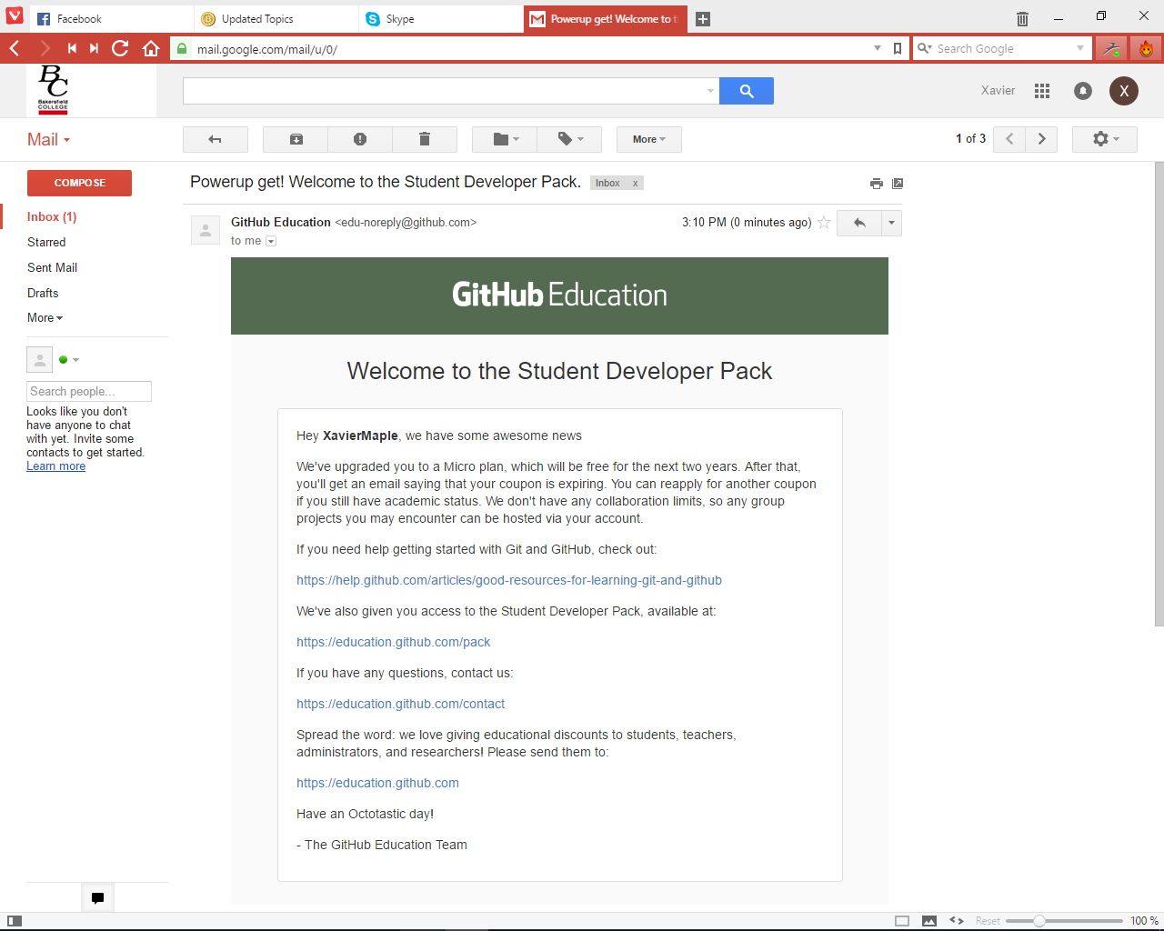

Click Get your pack and you will have everything you want

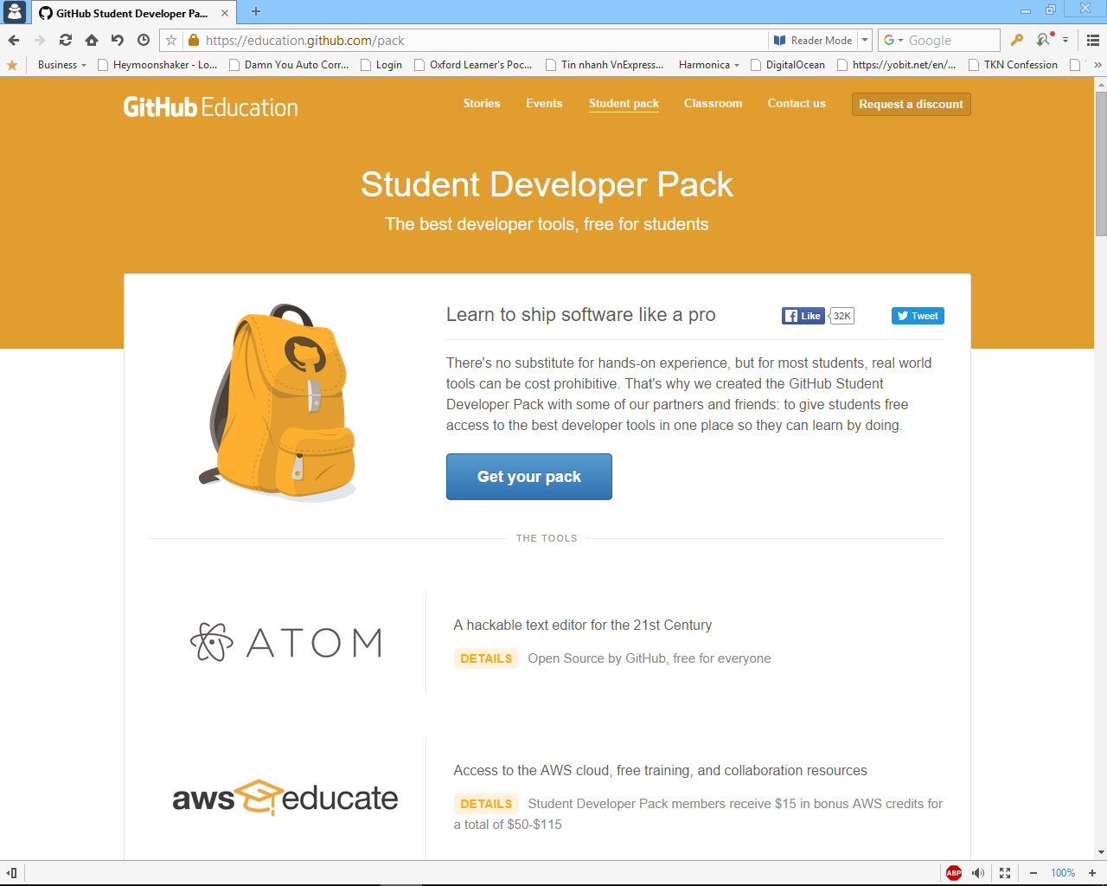

YOU CAN FIND MANY MANY USEFULL STUFFS THERE. .ME FREE DOMAIN, DIGITAL OCEAN COUPON, AWS COUPON… THE PROCEDURE FOR GETTING THEM IS QUITE EASY SO I WILL SKIP THROUGH IT.

1. **AutoDesk Stuff**

This should be easy I have to say. Go to: <http://www.autodesk.com/education/free-software/all>

Then click on any software (or the one you want. I will just choose 3ds Max)

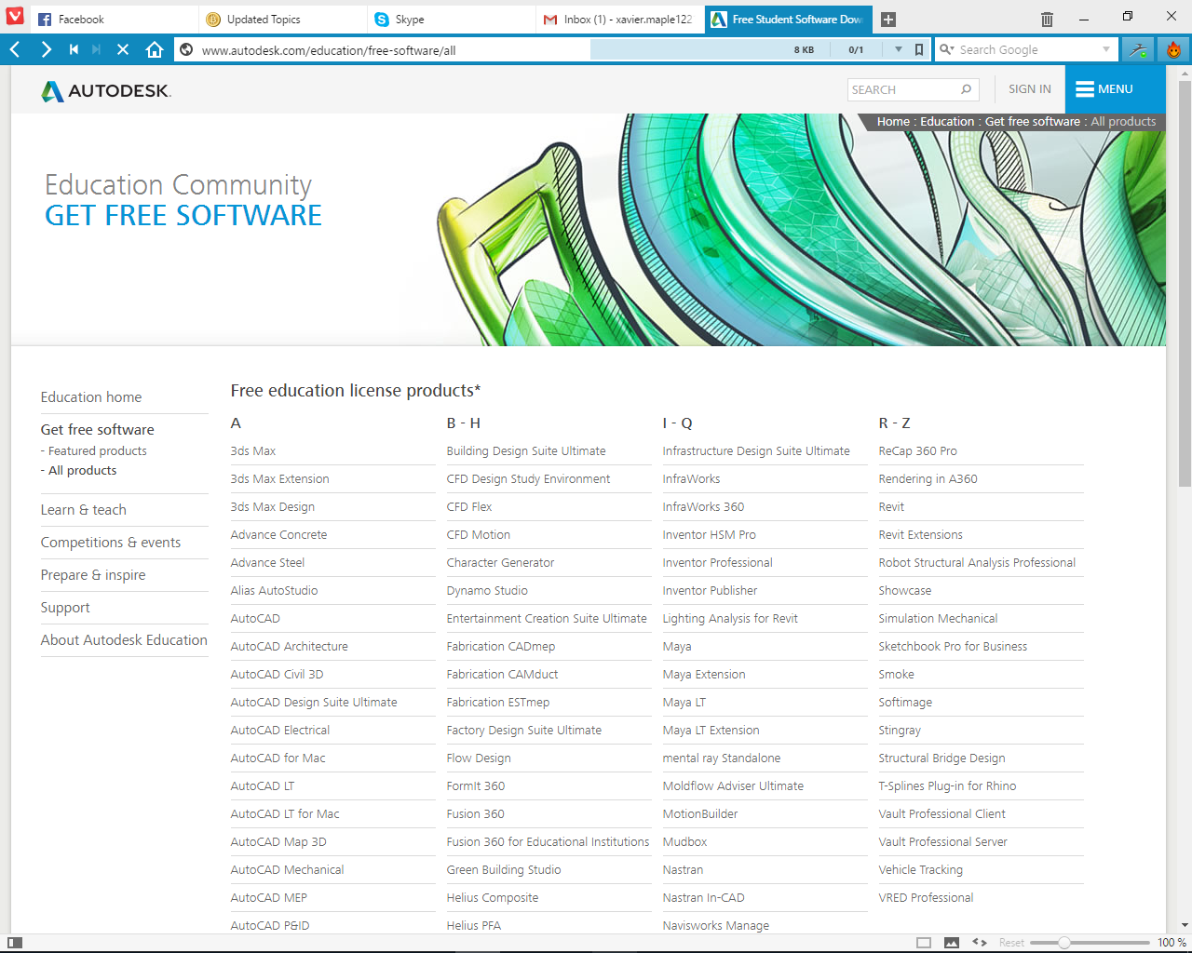

Then click Create an account

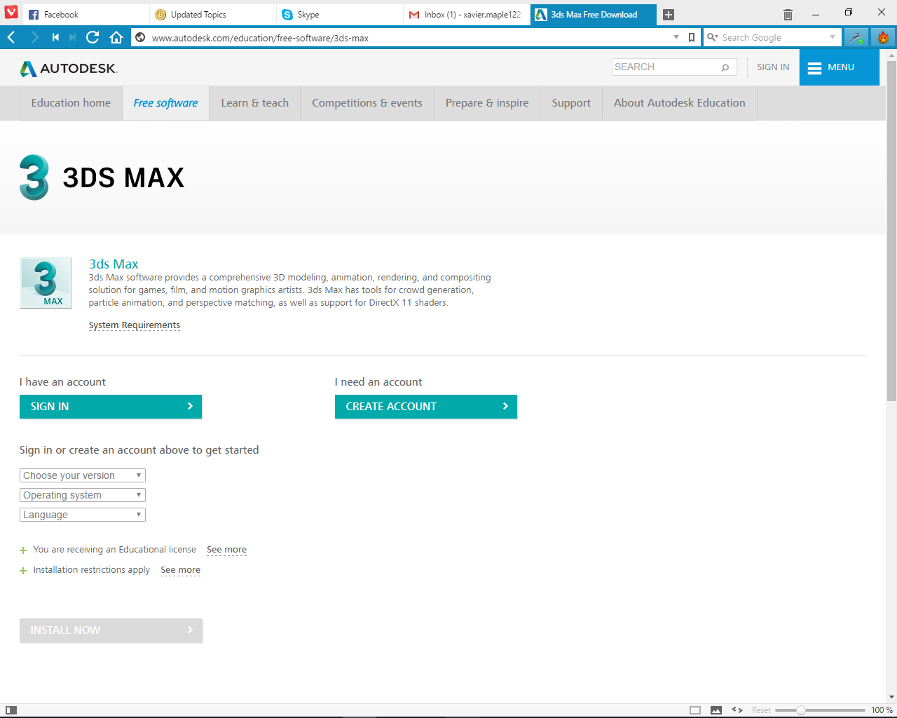

Just enter United States and Student Role. Any random date of birth (over 18 would be advised for sure) would work. Then click next

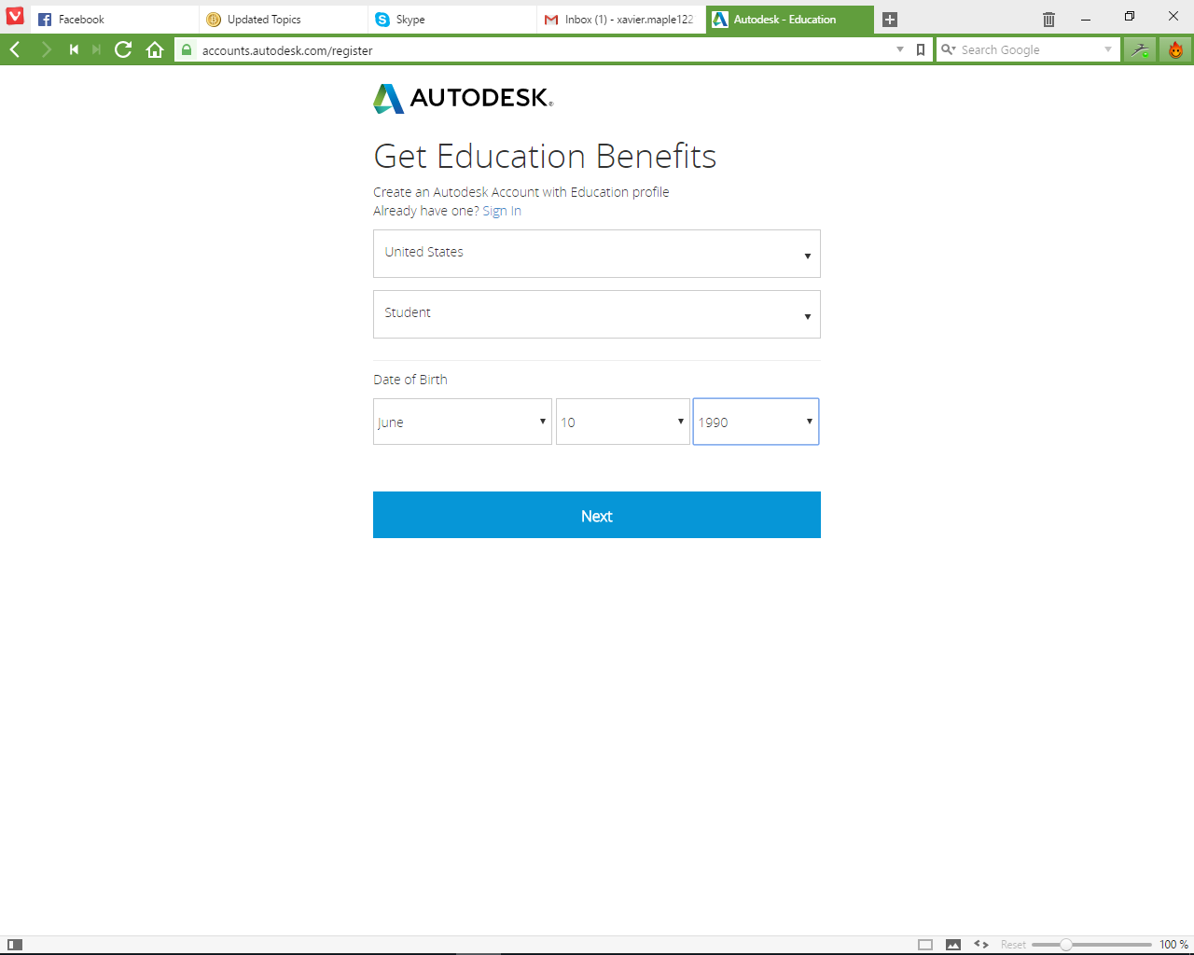

Fill in registration details (with your .edu email). Then click Sign Up

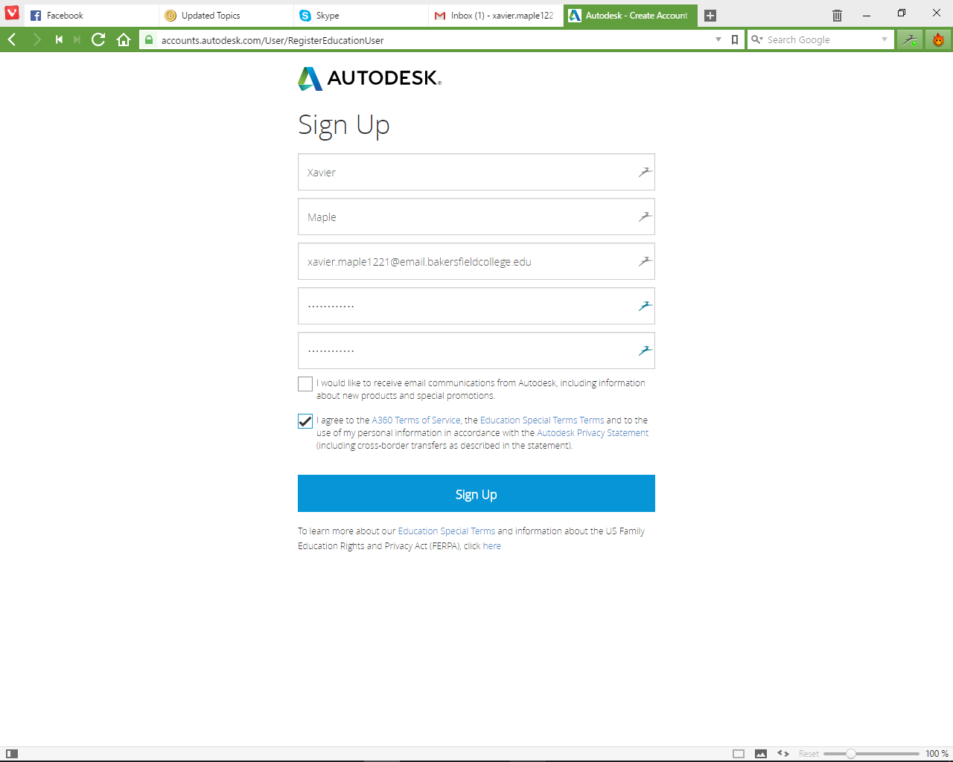

You will soon receive an email from Autodesk to verify the account. Click on the link to complete that.

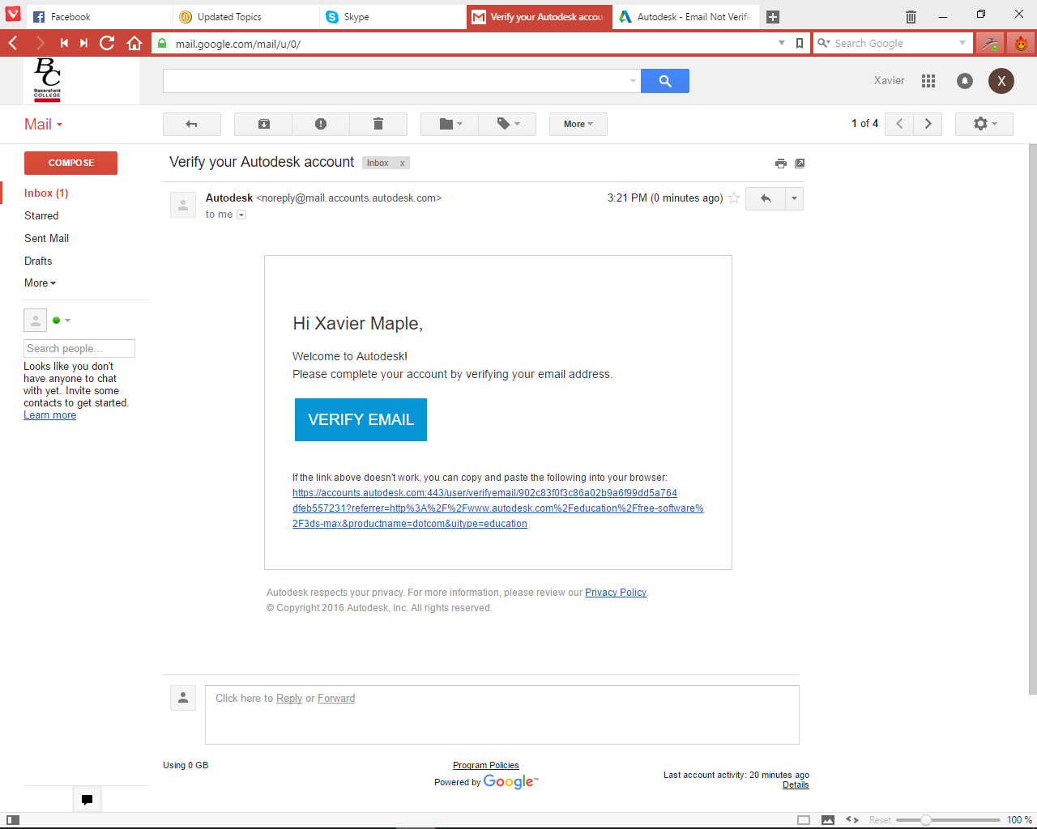

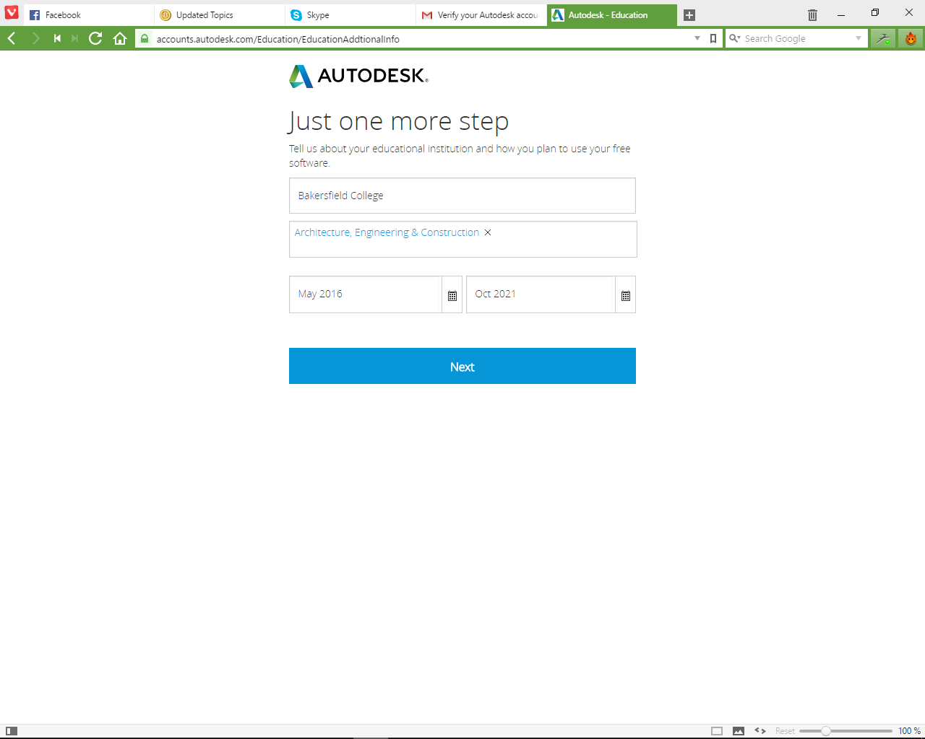Then click Sign in on the page you have just clicked which will guide you here. Fill the same as I did. Choose some far far away date like I did and click next.

Click Done and you will be guided back to the software you want. You will know what to do next.

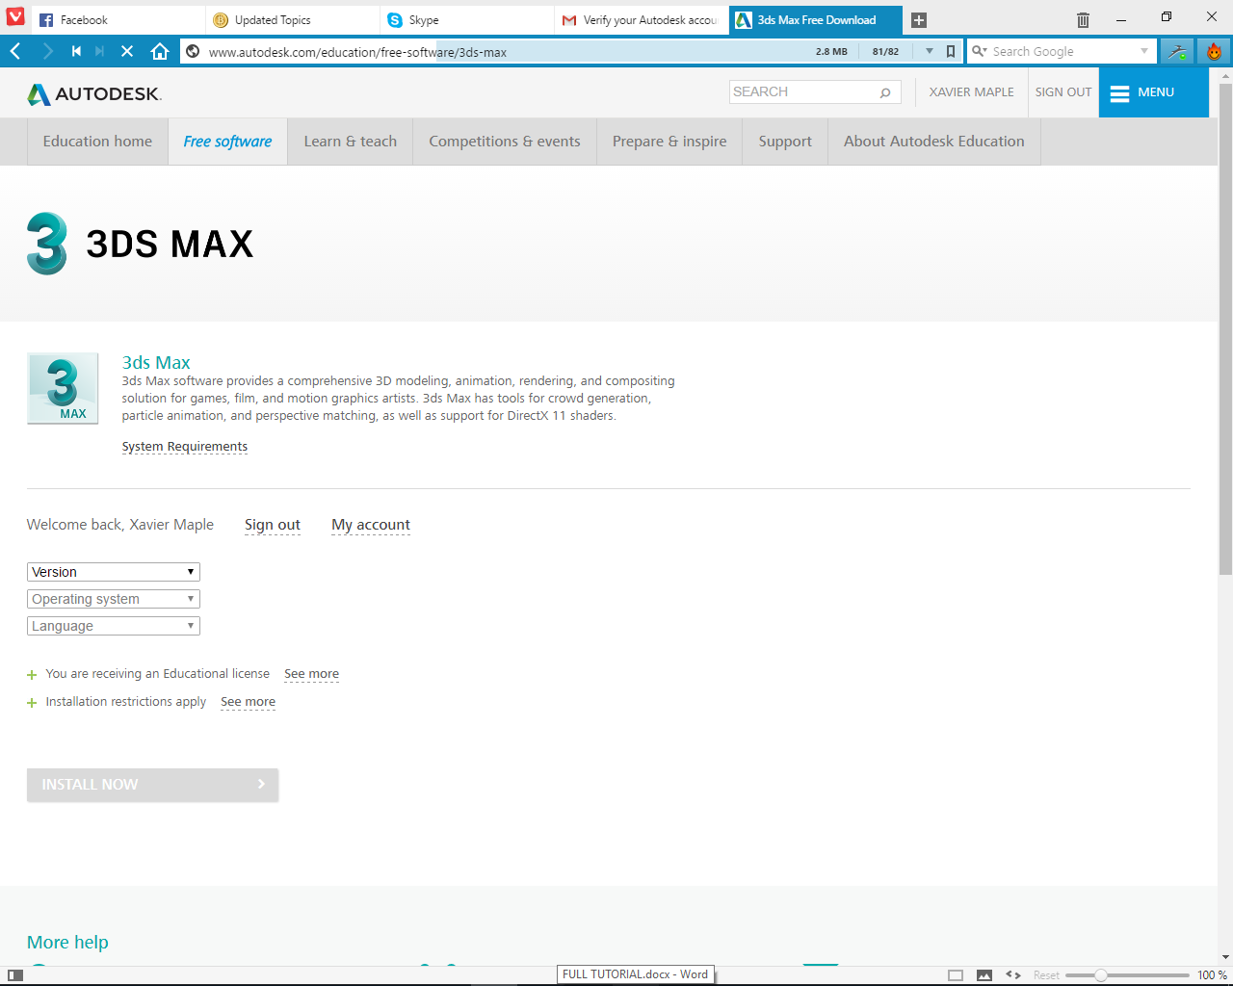

THAT’S THE END OF MY TUTORIAL. THE AMAZON PRIME SHOULD BE EASY ENOUGH FOR YOU TO DO IT BY YOURSELF. THANKS A LOT!